Project-EV:
Title: “Spatio-Temporal Forecasting of Municipal EV Charging Load Using Weather-Aware Transformer–LSTM Hybrid Models”

FULL RESEARCH PLAN

1. Problem Definition & Objectives

Problem Statement
Municipal EV charging stations introduce highly stochastic, weather-sensitive loads that challenge existing grid forecasting methods. Current approaches fail to jointly model:
- Station-level spatial heterogeneity
- Long-range temporal dependencies
- Weather-driven demand variation

Research Objectives
- Develop a weather-aware spatio-temporal EV charging load forecasting framework
- Accurately predict hourly municipal EV charging demand
- Evaluate model robustness during extreme weather events
- Provide actionable insights for urban grid planning

2. Dataset & Data Preparation

2.1 EV Charging Dataset (Primary)
- Source: Municipal Lots & Garages EV Charging Dataset
- Size: 211,384 charging sessions
- Key variables:
  - Energy Provided (kWh) → target variable
  - Charge Duration, Connected Duration
  - Station Name, Location Name
  - Date, Time

2.2 Weather Dataset (External)
- Source: NOAA or equivalent public weather API
- Variables:
  - Temperature
  - Humidity
  - Snowfall
  - Heat Index
- Temporal resolution: hourly
- Alignment: synchronized with EV load timestamps

2.3 Data Cleaning
- Remove invalid sessions
- Handle missing Driver ID / Location Name
- Outlier detection for energy values
- Normalize numerical features

2.4 Aggregation Strategy
- Aggregate charging sessions:
  - Hourly
  - Per station
- Compute:
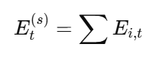

3. Feature Engineering

3.1 Temporal Features
- Hour of day (sin/cos encoding)
- Day of week
- Weekend indicator
- Holiday flag (optional)

3.2 Behavioral Features
- Idle Time = Connected Duration − Charge Duration
- Utilization ratio
- Average session length per hour

3.3 Weather Features
- Current weather
- Lagged weather (1–6 hours)
- Extreme weather indicators

4. Proposed Methodology
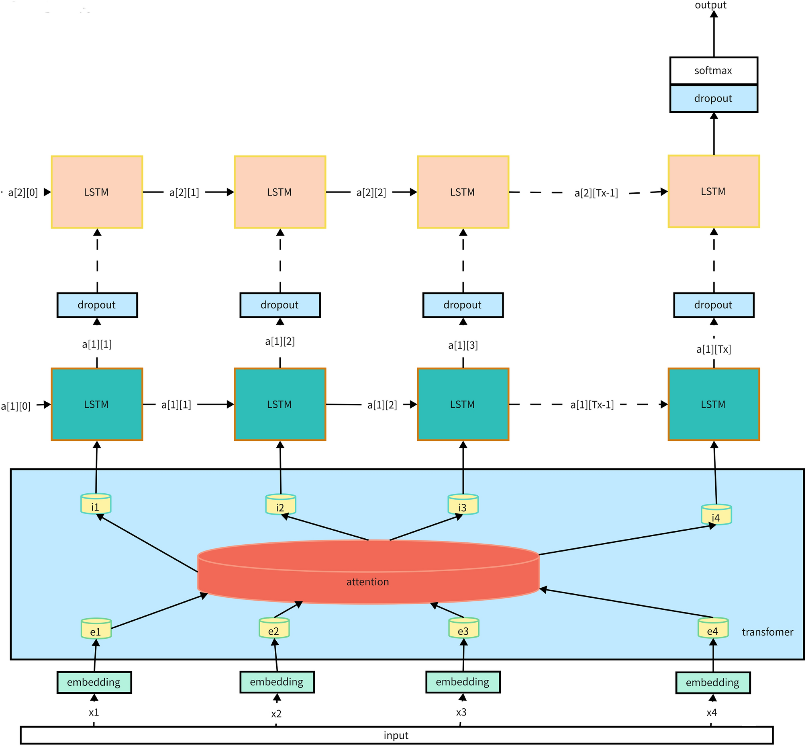

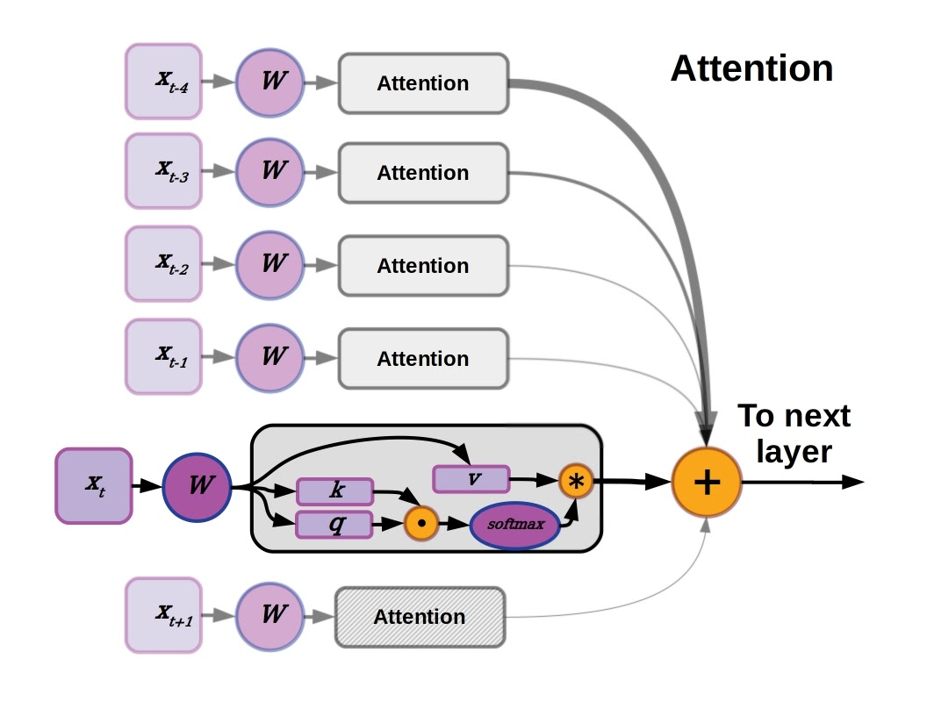

4.1 Model Architecture
Weather-Aware Transformer–LSTM Hybrid

Components:
- LSTM Encoder
  - Captures short-term dynamics
- Transformer Encoder
  - Models long-term dependencies
- Weather Fusion Layer
  - Integrates meteorological data
- Fully Connected Output Layer

4.2 Mathematical Formulation
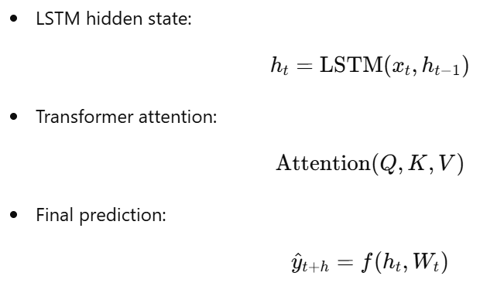

5. Experimental Design

5.1 Forecasting Tasks
- Short-term: 1–6 hours
- Day-ahead: 24 hours

5.2 Baseline Models
- ARIMA
- XGBoost
- LSTM
- Transformer

5.3 Training Setup
- Split: 70% train / 15% validation / 15% test
- Optimizer: Adam
- Loss: MSE
- Batch size: 64
- Epochs: 100

6. Evaluation Metrics
- RMSE
- MAE
- sMAPE
- Peak load error

7. Ablation & Sensitivity Studies

7.1 Weather Ablation
- With vs without weather inputs

7.2 Architecture Ablation
- LSTM only
- Transformer only
- Hybrid

8. Extreme Weather Analysis

8.1 Definition
- Heat waves
- Cold snaps
- Heavy snowfall

8.2 Performance Comparison
- Normal vs extreme conditions
- Error amplification analysis

9. Results & Discussion

9.1 Quantitative Results
- Performance tables
- Error reduction %

9.2 Visualization
- Actual vs predicted load
- Attention heatmaps
- Station-level load maps

10. Practical Implications
- Grid operation planning
- EV infrastructure expansion
- Demand response strategies
- Municipal energy policy

11. Limitations & Future Work
- Lack of real-time pricing data
- No vehicle SOC information
- Future:
  - Probabilistic forecasting
  - Graph Neural Networks
  - V2G modeling

12. Paper Structure (IEEE-Ready)
Section | Content
I | Introduction
II | Related Work
III | Dataset & Preprocessing
IV | Methodology
V | Experimental Setup
VI | Results & Discussion
VII | Conclusion

13. Expected Contributions
✔ Novel hybrid architecture
✔ Real municipal EV dataset
✔ Weather-aware forecasting
✔ Extreme-event robustness

